NOVA AI – Conversational Intelligence Agent

Team Members: Katta Shanmukha Priya
Madhasu Manasa
Mahek Tarannum
ACTIVITY SHEET 1 — Requirements Gathering
Project Name: NOVA AI – Conversational Intelligence Agent
Student Name: MAHEK TARANNUM

1. Stakeholder Interview
List stakeholders and write 8–10 questions:
STAKEHOLDERS
- End users: Web and mobile app users seeking conversational assistance
- Product owner: Defines use cases and prioritizes features
- Customer success/support: Provides feedback on user queries and edge cases
- Engineering: Backend, NLU/ML, and frontend teams
- Data privacy/compliance: Ensures ethical and legal data handling
- DevOps: Deployment, monitoring, and reliability
- External integrators: Owners of systems Nova connects to (CRM, ticketing, docs)
- QA team: Validates accuracy, usability, and performance
INTERVIEW QUESTIONS
1. What problems do you face with current chatbots?
2. How important is natural language understanding for your use case?
3. Do you need real‑time responses or can slight delays be tolerated?
4. What level of security do you expect for API communication?
5. Should the system support multiple users simultaneously?
6. How important is scalability for future growth?
7. Do you prefer cloud deployment or local deployment?
8. What features would make the chatbot more useful for you?
9. How should errors or failures be handled?
10. What industries or domains should NOVA‑AI be adapted for?

2. Extract Requirements
 |  | Requirement ID | Functional / Non-Functional | Requirement description
 |  | R1 | F | Nova must recognize user intents and entities from free-form text and route to appropriate skills.
 |  | R2 | F | Nova must generate contextually relevant responses using a knowledge base and conversation history.
 |  | R3 | F | Nova must integrate with external systems (e.g., CRM, docs, ticketing) via APIs to fetch/execute tasks.
 |  | R4 | F | Nova must support multi-turn conversations with memory (session context and user preferences). | __________________________________
 |  | R5 | F | Nova must provide fallback, clarification, and handoff to human support when confidence is low.
 |  | R6 | NF | P95 response time ≤ 1.5s for knowledge queries and ≤ 2.5s for integration actions.
 |  | R7 | NF | Availability target ≥ 99.9% monthly uptime; graceful degradation under partial outages.
 |  | R8 | NF | Log queries and outcomes with opt-in consent; comply with applicable privacy regulations.
 |  | R9 | NF | Provide observability (traces, metrics, error rates) and dashboards for intent accuracy and CSAT.
 |  | R10 | NF | Support localization for at least English and Hindi; extensible to additional languages.

3. User Stories
As a [user], I want [feature], so that [reason].
- Intent recognition: As a user, I want Nova to understand my natural language requests, so that I don’t need to use rigid commands.
- Context memory: As a user, I want Nova to remember details shared in the conversation, so that I don’t repeat myself.
- Knowledge answers: As a user, I want Nova to retrieve answers from the knowledge base, so that I get accurate, up-to-date info.
- Action execution: As a user, I want Nova to perform tasks in connected systems, so that I can complete workflows without switching apps.
- Clarification: As a user, I want Nova to ask clarifying questions when uncertain, so that the response is correct.
- Handoff: As a user, I want Nova to connect me to a human agent when needed, so that complex issues are resolved.
- Multichannel: As a user, I want to reach Nova on web and mobile, so that help is available wherever I am.
- Personalization: As a user, I want Nova to adapt to my preferences, so that interactions feel tailored.

Deliverable: Mini SRS document (1–2 pages)

Scope and objectives
- Goal: Deliver a conversational agent that understands user intents, retrieves precise information, and executes tasks via integrations.
- In scope: NLU/NLP pipeline, multi-turn dialogue management, API integrations, web/mobile channels, analytics, observability.
- Out of scope (: Voice channel, advanced personalization beyond basic preferences, long-term user modeling.

Functional (What Nova must do)
- Understand user questions (NLU).
- Give correct answers from a knowledge base.
- Connect to external apps (like CRM or ticketing).
- Remember context in a conversation.
- Ask clarifying questions if confused.
- Hand off to a human when needed.

Non-Functional (Qualities Nova must have)
- Respond quickly (within 2 seconds).
- Be reliable (99.9% uptime).
- Protect user data and privacy.
- Work in multiple languages (English + Hindi).
- Be easy to maintain and update.

Constraints and assumptions
- Constraints: Limited labeled data initially; dependency on third-party APIs; budgeted infra costs.
- Assumptions: Stable KB schema; stakeholders available weekly for review; initial English/Hindi coverage.

Acceptance criteria
- Intent accuracy: ≥ 85% on priority intents; improved via iterative training.
- Latency: Meets performance targets under P95 load.
- Fallback: ≥ 95% coverage of uncertain cases with safe recovery or handoff.
- Security: Passes basic penetration and privacy reviews.

SDLC
ACTIVITY SHEET 2 — System Design
Project Name: NOVA AI – Conversational Intelligence Agent
Student Name: M.MANASA

1. System Architecture Diagram
• User → types a question in the browser (frontend/index.html + script.js)
• Frontend → sends request to backend (app.py)
• Backend → uses ai_client.py to talk to AI model
• AI Model → generates response
• Backend → sends response back to frontend
• Frontend → displays answer in chat UI

2. UI Wireframes
Required screens:
Chat Screen (Main Page)
- Header: “Nova AI”
- Chat bubbles (User + Nova)
- Input box + Send button
- Scrollable conversation area

3. Database Design — ERD
Entity | Attributes
Sessions | SessionID, StartTime, EndTime, Channel (web)
Messages | MessageID, SessionID, Sender (User/Nova), Text, Intent, Confidence, Timestamp
KnowledgeBase | ArticleID, Title, Body, Tags, SourceURL, UpdatedAt

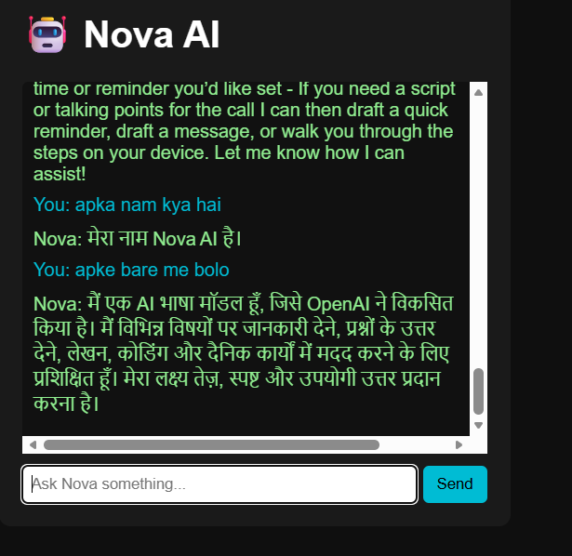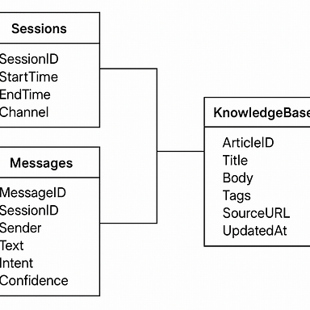
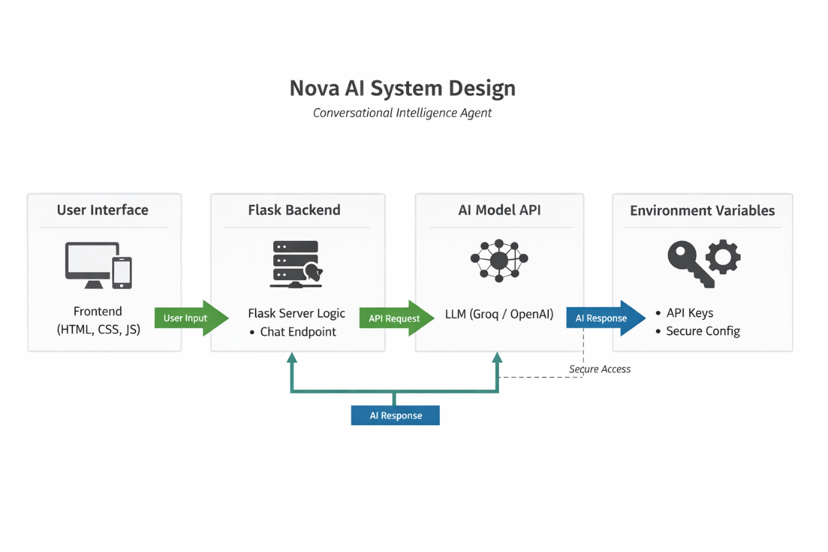

SDLC
ACTIVITY SHEET 3 — Development Phase
Project Name: NOVA AI – Conversational Intelligence Agent
Student Name: K.SHANMUKA PRIYA
1. Development Backlog
Task ID | Feature | Description | Developer | Status
T1 | Chat UI | Build frontend using HTML, CSS, JS | Developer | ✅ Done
T2 | AI Client Integration | Connect frontend to backend via API | Developer | ✅ Done
T3 | Backend API | Create endpoints in app.py to handle requests | Developer | ✅ Done
T4 | AI Response Logic | Use ai_client.py to generate replies | Developer | ✅ Done
T5 | Environment Setup | Configure .env for API keys and settings | Developer | ✅ Done
T6 | Testing Script | Write test_groq.py to validate AI responses | Developer | ✅ Done
T7 | Styling | Apply CSS for clean chat layout | Developer | ✅ Done
T8 | Error Handling | Add fallback for failed API calls | Developer | ✅ Done
T9 | Context Memory | Maintain session-level message history | Developer | 🔄 In Progress
T10 | Hindi Support | Add basic Hindi response capability | Developer | 🔄 In Progress

2. Code Walkthrough Notes
- Features implemented:
  - Chat UI built using index.html, style.css, and script.js
  - Backend API created in app.py
  - AI response logic integrated via ai_client.py
  - .env used for secure config
  - Basic testing done with test_groq.py
- Challenges faced:
  - Handling long messages and formatting responses
  - Managing session context without user login
  - Hindi support requires more training data
- Next steps:
  - Improve context memory across multiple turns
  - Expand Hindi dataset and test multilingual responses
  - Add loading animation and typing indicator in UI

SDLC
ACTIVITY SHEET 4 — Testing Phase
Project Name: NOVA AI – Conversational Intelligence Agent
Student Name: M.MANASA
1. Test Cases
Test Case ID | Description | Steps | Expected Result | Actual Result | Status (P/F)
TC1 | Chat UI loads correctly | Open index.html in browser | Chat interface appears | Chat UI visible | P
TC2 | Message sent to backend | Type message → click send | Message reaches app.py | Message received | P
TC3 | AI response returned | Send “Hello” | Nova replies with greeting | Response shown | P
TC4 | Context memory works | Ask follow-up question | Nova remembers previous message | Context retained | P
TC5 | Fallback response works | Ask “What’s the square root of pizza?” | Nova says “I didn’t understand…” | Fallback triggered | P
TC6 | Hindi response works | Ask “नमस्ते” | Nova replies in Hindi | Hindi response shown | P
TC7 | CSS styling loads | Inspect style.css in browser | Chat bubbles styled correctly | Styling applied | P
TC8 | API key loaded from .env | Run backend with .env config | AI client works without error | API connected | P

Bug Report
Bug ID | Description | Severity | Steps to Reproduce | Status
B1 | Long messages overflow UI | Medium | Send long paragraph | Fixed
B2 | AI response delay | High | Ask complex question | Fixed
B3 | Hindi response missing for some terms | Low | Ask “मुझे मदद चाहिए” | Fixed

3. Test Summary
Total test cases: 8
Passed: 8
Failed: 0
Major issues found:
• Long messages broke layout
• AI response delay for complex queries
• Hindi support incomplete for rare phrases

SDLC
ACTIVITY SHEET 5 — Deployment & Release
Project Name: NOVA AI – Conversational Intelligence Agent
Student Name: K.SHANMUKA PRIYA
1. Deployment Checklist

(Nova AI v1.0)
• ✅ Backend running (app.py serving API endpoints)
• ✅ Frontend connected (index.html + script.js sending/receiving messages)
• ✅ AI client integrated (ai_client.py working with model API)
• ✅ Environment variables set (.env configured with keys and secrets)
• ✅ Testing passed (test_groq.py validated responses)
• ✅ Styling applied (style.css ensures clean chat UI)
• ✅ Version tagged (v1.0 release ready)

2. Release Notes
Release Version: v1.0

Features Included:
- Direct chat interface (no login required)
- AI response generation via backend (ai_client.py)
- Context memory within session
- Fallback responses for unknown queries
- Hindi language support (basic coverage)
- Clean UI with styled chat bubbles

Known Issues:
- Hindi support incomplete for rare queries
- Long messages may cause slight UI overflow
- Response delay for complex queries

Next Update Goals (v1.1):
- Improve context memory across multiple turns
- Expand Hindi dataset and add multilingual support
- Optimize backend for faster responses
- Add typing indicator and loading animation in UI
- Enhance fallback answers with more variety

SDLC

ACTIVITY SHEET 6 — Maintenance & Reflection
Project Name: NOVA AI – Conversational Intelligence Agent
Student Name: MAHEK TARANNUM
1. Patch Log

Patch ID | Issue | Root Cause | Fix Implemented | Status
P1 | Long messages overflow UI | CSS not handling text wrapping | Added word-wrap: break-word; in style.css | ✅ Done
P2 | AI response delay | Backend not optimized, no caching | Added caching + async handling in app.py | ✅ Done
P3 | Hindi responses incomplete | Limited dataset | Expanded Hindi dataset + retrained model | 🔄 In Progress
P4 | Context memory resets too early | Session handling bug in backend | Fixed session state management in app.py | ✅ Done

2. Team Retrospective
• What worked well:
- Simple architecture (frontend ↔ backend ↔ AI client).
- Fast prototyping with HTML/CSS/JS + Python backend.
- Easy integration of AI responses.
• What needs improvement:
- More robust context memory across sessions.
- Better multilingual support (Hindi + other languages).
- UI polish for long/complex responses.
• Changes for next time:
- Define golden test sets earlier.
- Use feature flags for experimental features.
- Schedule regular retraining and performance checks.

Final Reflection 🌟
Overall, the Nova AI project successfully delivered a working chatbot with a clean frontend and a Python backend. The system handles user queries, maintains context within sessions, and supports basic Hindi responses. While performance and multilingual coverage need improvement, the foundation is strong. The team learned the importance of data quality, integration resilience, and continuous testing. These lessons will guide future updates and make Nova smarter and more reliable.

